2025

Nonso Nkire

N12066095

10/5/2025

CAB230 Assignment 2 Client Side



CAB230

Movies API – Client Side Application

Contents

Introduction 3

Purpose & description 3

Completeness and Limitations 4

Use of End Points 4

/movies/search 4

/movies/data/{imdbID} 5

/people/{id} 6

/user/register 7

/user/login 8

/user/refresh 8

/user/logout 9

Modules Used 10

Axios 10

React-router DOM 10

React-hot-toast 10

Zustand 11

React-country-flag 11

Chart.js 11

React-chartjs-2 11

Lucide-React 11

TailwindCSS 11

Application Design 12

Navigation and Layout 12

Usability and Quality of Design 13

Accessibility 13

Technical Description 14

Architecture 14

Test plan 15

Difficulties / Exclusions / unresolved & persistent errors 16

User guide 16

Home Page 16

Registering a New Account 16

Logging In 17

Browsing and Searching Movies 17

Movie Details 18

Person Details 18

Logging out 19

References 20

Appendices 21

01 21

02 21

03 22

04 22

05 23

06 23

07 24

08 24

09 25

10 25

11 26

12 26

13 27

14 27

## Introduction

### Purpose & description

This movie explorer is a React-based application that allows users to search, browse and view deeper analytical information for a curated dataset of films released between 1990 and 2023 using a REST API. The application contains keyword and year-based search functionalities, paginating through the full catalogue of results. Users can view detailed metadata and box-office figures for each film, and once authenticated, explore cast and crew filmographies complete with visual IMDB rating charts. Programmatically, the application leverages modern React patterns such as React Router v6 for navigation, and stores session state (JWTs and Refresh tokens) in localStorage for seamless token renewal and logout functionality.

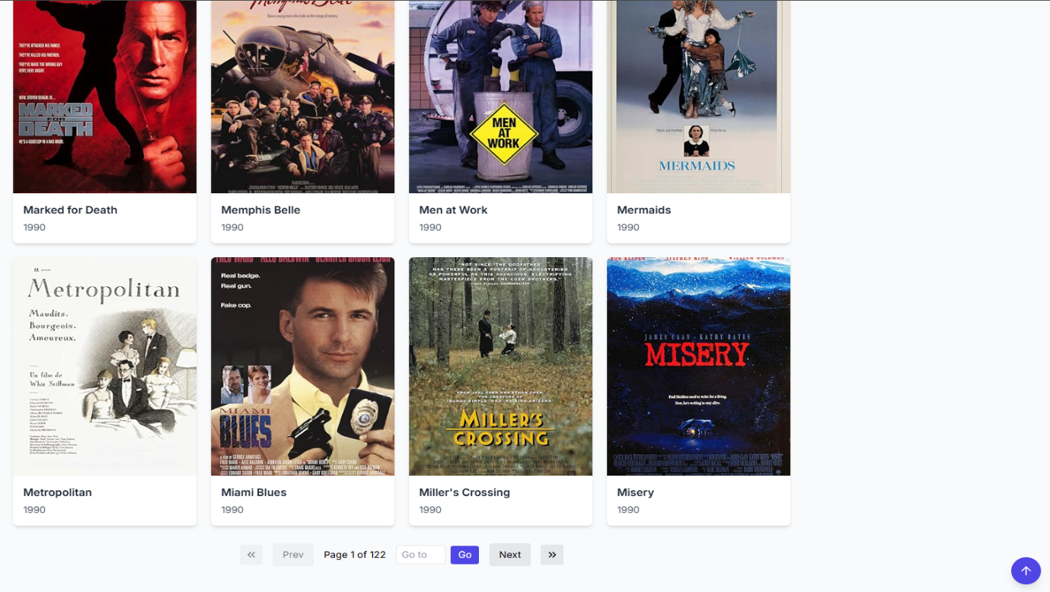Beyond the core requirements, several enhancements have been made to improve the overall functionality of the application. Instead of heavy grid libraries, the application implements custom pagination control that fully exposes the API’s paginated search data without significant performance impacts or rate-limit risks. For styling, Tailwind CSS is used to deliver a cohesive design system that incorporates smooth CSS-only animations including micro-interactions on buttons, cards and tooltips. React-country-flag is used to display the flags of the first two countries the movie was released in, alongside the movie’s runtime and release year. For the IMDB filmography analytics, react-chartjs-2 was used to render IMDB ratings over the course of an actor’s career, and allows users to filter through the ratings of each movie the individual has been involved in. Finally, JWT-based authentication is managed through Zustand and Axios interceptors to create efficient token refresh functionality.

*Figure 1: Search form with first/last/ “go to” pagination controls*

#### C*ompleteness and Limitations*

*Figure 2: Detailed film view with box-office, ratings, and movie navigation arrows.*

All public and authenticated endpoints are fully implemented and function reliably after some testing, meeting the criterion for a grade 7 by exposing every page of search results without infinite scroll. Controlled inputs, sophisticated error handling and a professional design all work cohesively to ensure a smooth user experience. Minor performance latency is present when dealing with large pages of posters, however this only occurs due to extensive testing and rapid jumping from page to page. Any major performance issues have been mitigated via caching; however, implementation of additional ARIA (Accessible Rich Internet Applications) attributes could improve accessibility. Ultimately, the application exceeds the specification’s core expectations in both functional and design aspects.

## Use of End Points

#### /movies/search

A search form that accepts title keywords as well as optional year filters and returns up to 100 matching films per page using the same response movie cards as seen on the main search page. Custom controls (first/prev/next/last and “go to”) drive the page parameter and expose the complete dataset.

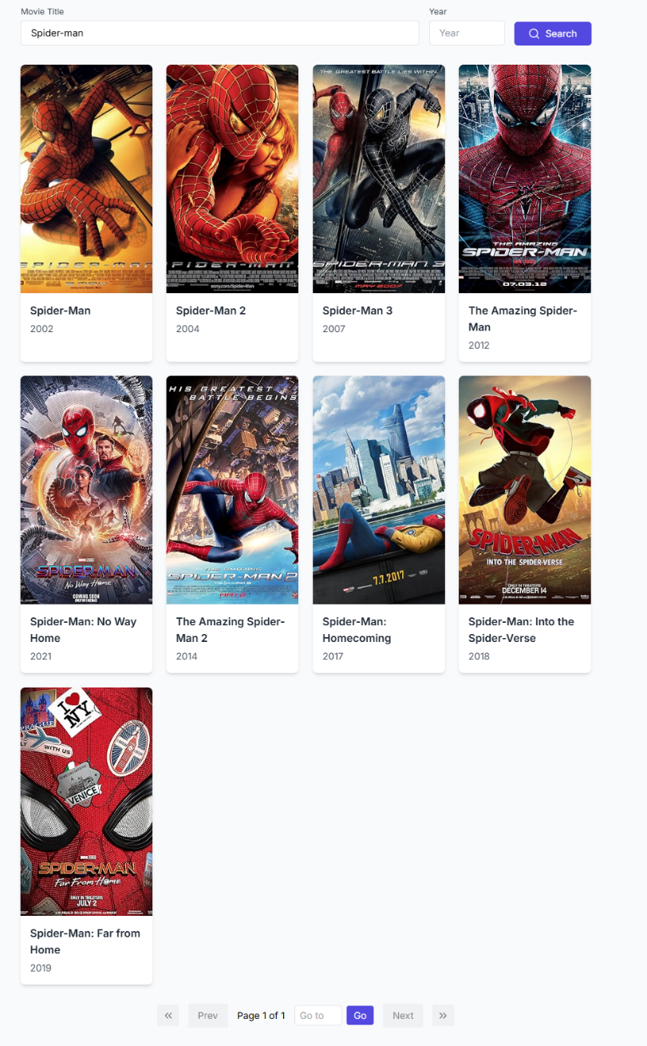

*Figure 3: Paginated search requests with query params title and year returning the first page of movie results.*

#### /movies/data/{imdbID}

Complete metadata for a single film is fetched by its IMDB ID. The view displays the poser, genres, runtime, release year, box-office sales figures, some flags for country of origin, ratings, plot summary and cast & crew listing with next/previous navigation functionality.

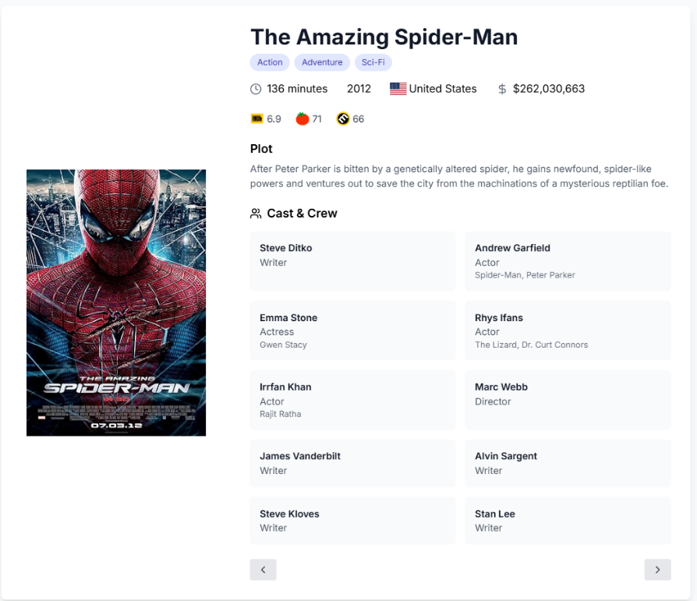

*Figure 2: Detailed movie metadata request for a single film, returns full information including plot, title, genres etc.*

#### /people/{id}

Verified users view filmographies by person ID. The filmography table has sorting and paginating capabilities, and a chart (via react-chartjs-2) that displays IMDB ratings across that person’s career.

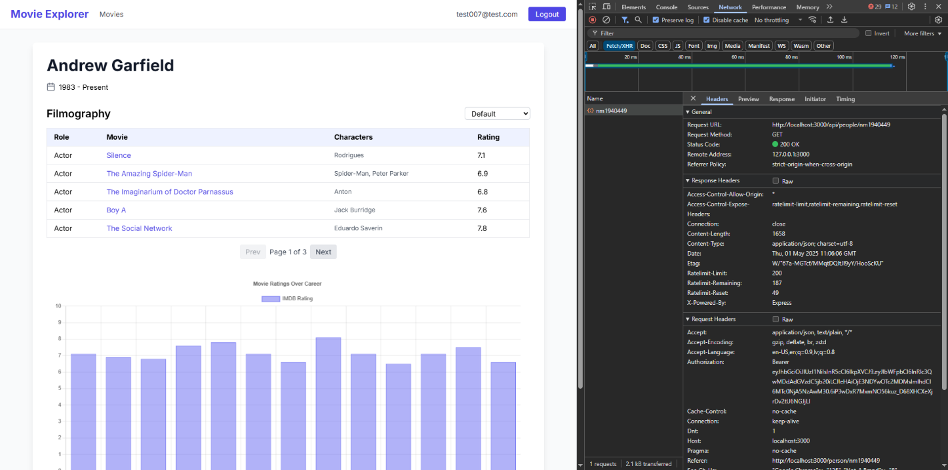

*Figure 4: Request for a person’s filmography (e.g nm1940449) including the Authorization: Bearer <token> header.*

#### /user/register

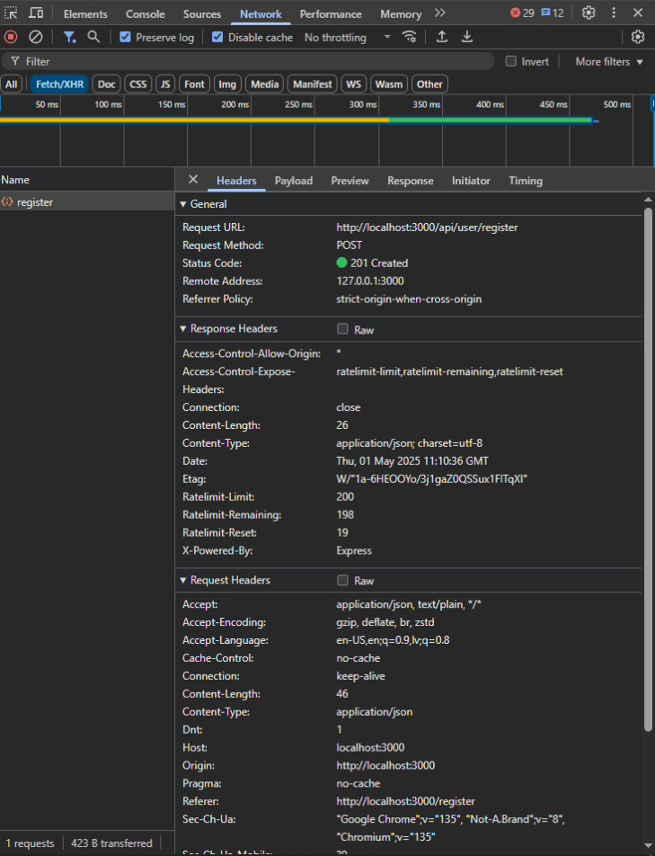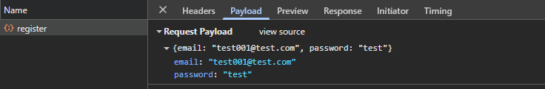The registration form includes email and password fields. Upon submission, the form sends these fields via POST to /user/register. Success and error messages are shown immediately, guiding the user to the login page upon successful account creation.

*Figure 5: Payload of register, displays email and password fields*

*Figure 5(B): Registration call with 201 response.*

#### /user/login

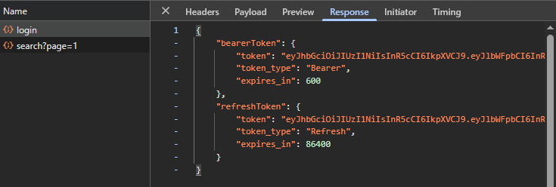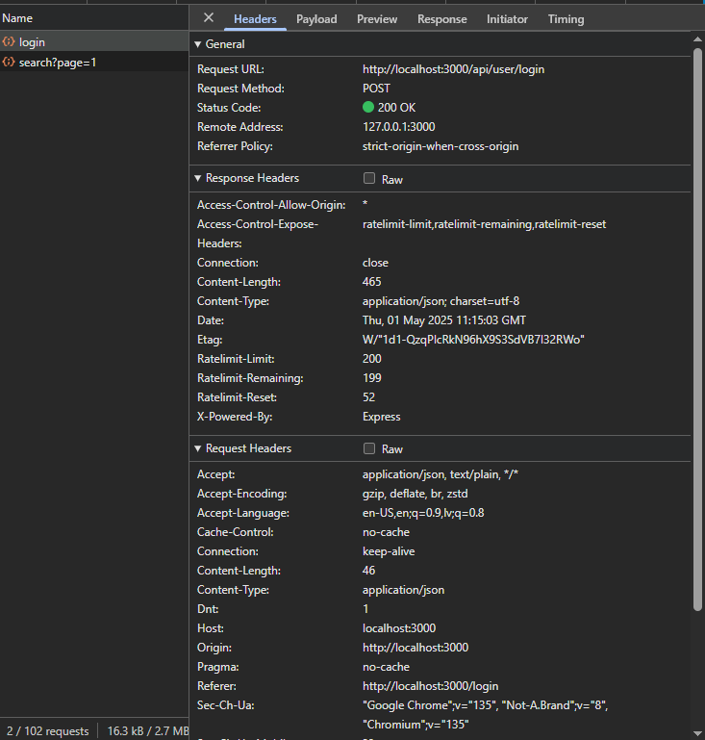Credentials are submitted to /user/login in order to obtain a bearer token and refresh token. The tokens are stored in localStorage and attached to all requests that are sent afterwards. If the credentials were incorrect, specific error messages will be raised.

*Figure 6: Login call and response containing bearerToken and refreshToken objects, confirming successful authentication.*

#### /user/refresh

An Axios interceptor automatically calls this endpoint upon receiving a 401 response a valid refresh token. A new bearer token is retrieved and injected into the original request, preventing forced logouts and maintaining session continuity.

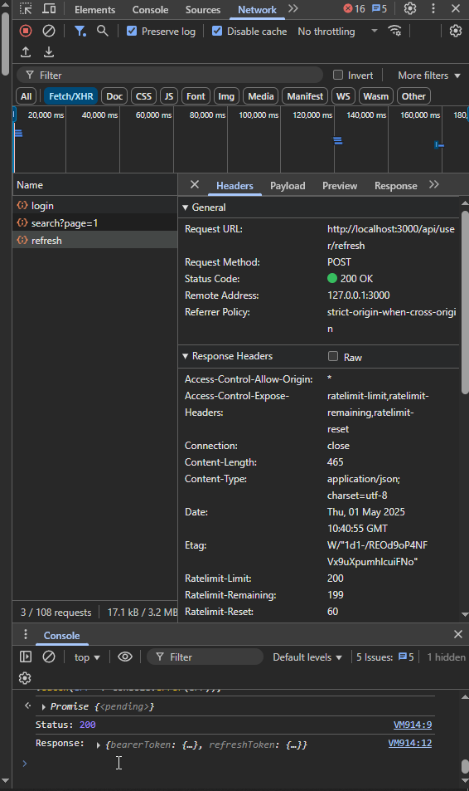

*Figure 7: Token-refresh call using stored refresh token which allows for session continuation.*

#### /user/logout

A logout action calls /user/logout, revoking the refresh token server-side. LocalStorage is cleared of both access and refresh tokens, the auth store is reset and the user is redirected to the login page.

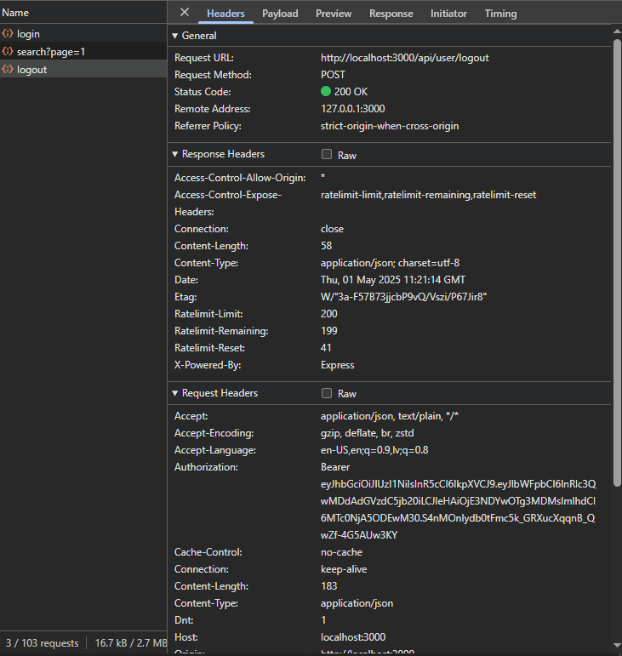

*Figure 8: Logout call (with Authorization header) returning 200 OK status, indicating server-side invalidation of the current tokens.*

## Modules Used

#### Axios

Promise-based HTTP client for browsers and Node.js, was used for all API requests (GET, POST, etc)

<https://axios-http.com/> | <https://www.npmjs.com/package/axios>

#### React-router DOM

A declarative routing library for React web apps, allows URL-driven navigation and protected routes.

<https://reactrouter.com/>

#### React-hot-toast

A lightweight, customizable toast and notification library for React applications, was used to display status messages such as errors and successes.

<https://react-hot-toast.com/>

#### Zustand

A small, fast and highly scalable state-management system using React hooks, was used to manage authentication state (via a persisted store)

<https://github.com/pmndrs/zustand>

#### React-country-flag

Simple React component for rendering country flags as SVGs given an ISO 3166-1 alpha-2 code.

<https://www.npmjs.com/package/react-country-flag>

#### Chart.js

Flexible JavaScript charting library that provides the core chart functionality.

<https://www.chartjs.org/>

#### React-chartjs-2

A React wrapper for Chart.js, allowing for easy integration of bar and line charts in React components

<https://github.com/reactchartjs/react-chartjs-2>

#### Lucide-React

A community-driven icon library delivered as React components, used for UI icons like arrows, clocks, stars etc.

<https://lucide.dev/>

#### TailwindCSS

A CSS framework for building custom designs using markup, essentially all animations and styling within the app was done using Tailwind.

<https://tailwindcss.com/>

## Application Design

### Navigation and Layout

The overall design process of the application was centered on the idea of simple, professional, and responsive usability. Certain design choices were made based on personal experience navigating similar sites, thus it was important to ensure that users were able to search and explore movies with minimal friction while also maintaining a sleek modern aesthetic. Navigating around the site is primarily handled with a top navbar built with React Router so users can quickly navigate to the home, movie and login/register routes (which dynamically change based on the state of user authentication). Once logged in, the user’s email is displayed, and access to authenticated routes is enabled. If an authenticated users attempts to navigate to that page directly, they would be redirected to the register page with a toast message indicating signing up was required.

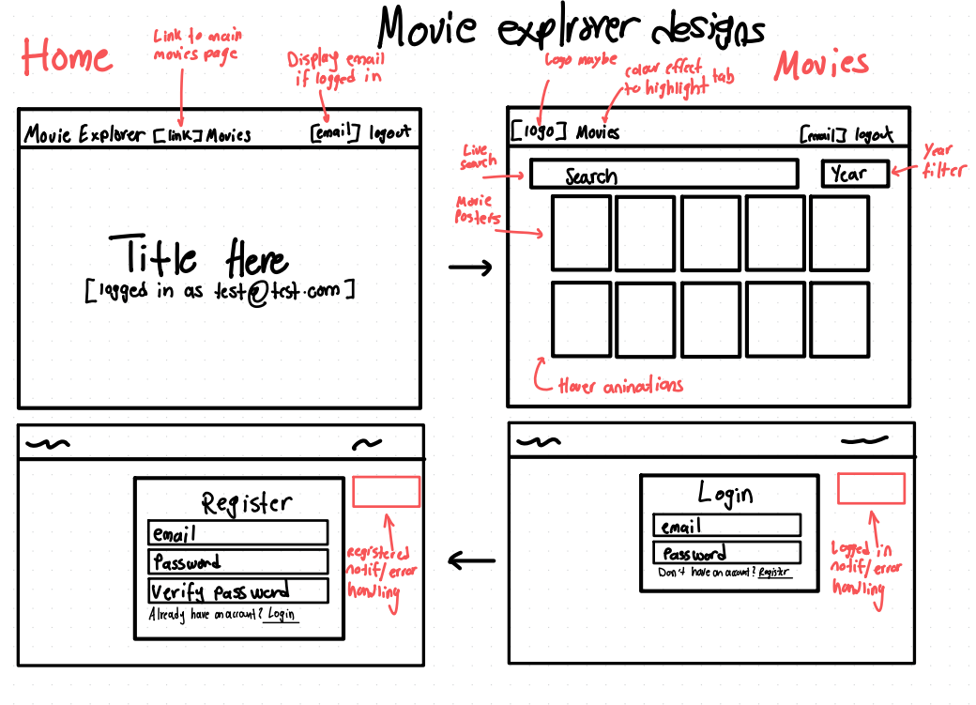The main movies page allows users to filter by either title or year and displays results in a response grid with smooth pagination that extends beyond the first 100 results using server-sided page handling. Since the API does not include poster data in the search endpoint, a secondary call to the /movies/data/{imdbID}endpoint was implemented for each search result to fetch detailed information including the poster. This was inspired by platforms like IMDb and Netflix with the goal of creating a visually rich and familiar browsing experience that users would intuitively expect. Each result card links the user to a detailed view of the movie with information about the cast, ratings, country of origin (including flags) and forward/back navigation functionality, part of the effort to create a seamless browsing experience. Personal cast/crew details are available as well; this includes a sortable paginated filmography table with an IMDb ratings chart to visualize their work. Finally, the last design consideration was the implementation of infinite scrolling. While it was initially considered, it was removed due to performance impacts as a result of increased API pressure caused by fetching poster images. However, the implemented pagination provided a more user-friendly solution. The figure below shows the early designs of the layout and screen flow, which served as the practical foundation for the final application.

*Figure 9: Early design sketches of the home page, search page, login and register page*

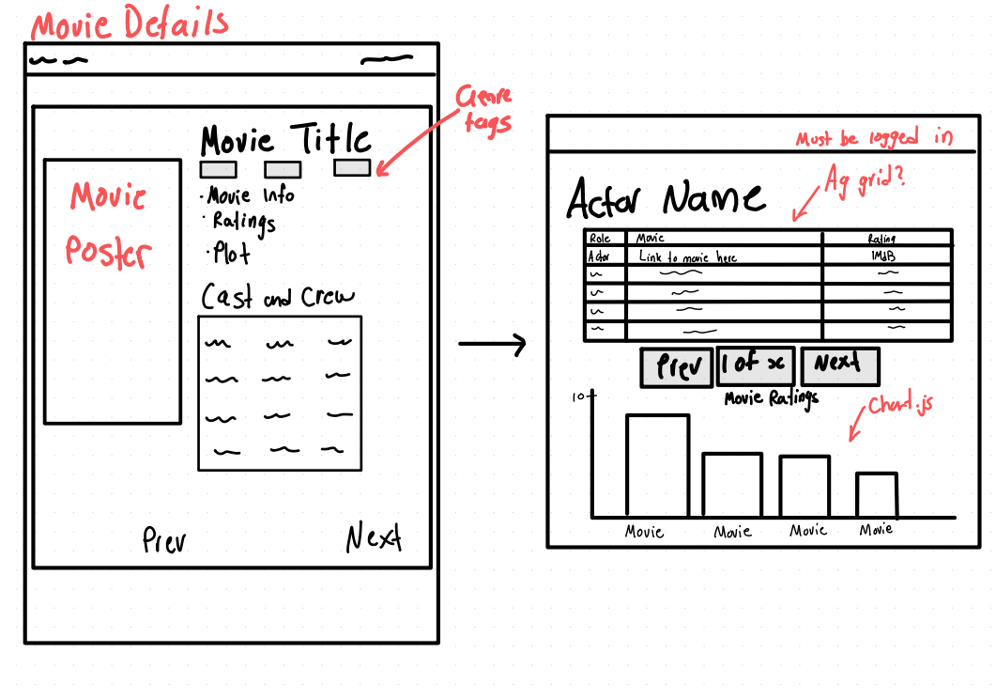

*Figure 10: Early sketches of the movie details page alongside the cast/crew member details including the chart component.*

### Usability and Quality of Design

Overall, the app presents a logically organized experience with clearly defined sections for navigation, search input, results display and detailed views. The layout follows typical user expectations and visuals that are influenced by popular media streaming platforms which invokes a sense of familiarity within users. Navigation throughout the site is intuitive. Pages load quickly and the flow from Movies → Movie Details → Cast → Person Details feels natural. Interactive elements such as search, filters and sorting are placed exactly where users would expect to find them. The only downside however small, is that the search form does not persist across pages (e.g., when returning from a detail page), which disrupts the experience when exploring through multiple films. It’s clear that implementing more persistent or global filters would improve flow for frequent users.

From a visual standpoint, the site is clean and consistent. Only select few fonts and font sizes were used, and the accent colour indigo is consistently used for interaction cues such as buttons, links, highlights, which strengthens the visual appeal of the site. Animations are subtle and are used to positively impact user experience. However, there are opportunities to simplify spacing, minimise vertical scrolling, particularly on mobile viewports (which were not considered to any significant extent). Furthermore, while the chart component is informative, its design could benefit from clearer axis labels and possibly more interactive elements.

### Accessibility

Using the W3C Priority 1 guidelines as a framework:

* All non-text elements, such as rating source icons and country flags, includes alt text or title attributes, thus, the application fulfils the “Text equivalents for non-text elements” requirement. Additional enhancements could be implemented by adding descriptive aria-labels to key icons for screen reader users.
* The site leverages colour as visual enhancement (e.g. box office earnings, genre pill tags), but all functionality and meaning are effectively conveyed via text and layout as well. The application would remain equally functional even in grayscale or high-contrast modes. Therefore, site information is not dependent on colour.
* The structure of the site is readable without styles, but some layout and ordering could become disjointed if styling is stripped, especially the grid-based elements. To improve this, semantic HTML such as <section>, <main> and <article> could be introduced for better fallback structure.
* Since there is no content in the app that dynamically updates without user interaction, there’s hardly any risk of screen reader content becoming outdated. The chart could be an issue if modified in future versions, however currently, it is static post-render.
* There are no flashing or flickering components present throughout the UI. All transitions and animations are smooth and non-intrusive.
* The language used across UI components is simple, easy to understand and appropriate for a general audience. Tooltips and navigation items are void of verbose language and instead use intuitive labels such as “search”, “login” etc.
* Despite the filmography table use semantic <thread> and <tbody> tags, explicit labelling of column headers using <scope= “col”> should be added to improve overall accessibility for screen readers.

## Technical Description

### Architecture

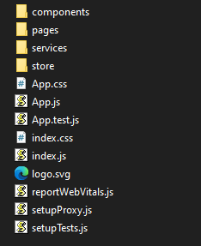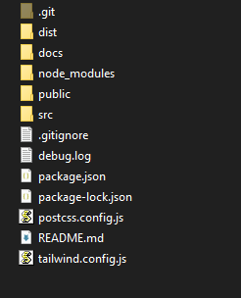The source code is organized using standard React project structure, which focuses on modularity and separation of responsibilities.

*Figure 12: Structure of src directory*

*Figure 11: Top-level directory structure*

Figure 11 shows the structure of the top-level directory for the project. This directory contains configuration files such as package.json and tailwind.config.js alongside build artifacts in the dist folder, and all application logic housed in the src folder. Within the src directory, key responsibilities are clearly divided into sub folders to streamline development and enhance code maintainability. Figure 12 shows:

* The components/ folder, which contains reusable UI components. Components such as the movie cards and rating charts are housed here.
* The pages/ folder contains route-based screens such as Movies, Home, Login and Person Details (filmography page)
* The services/ folder defines the API logic using Axios.
* The store/ folder manages global application state, including authentication via Zustand.

All routing is handled through React Router, utilizing App.js to coordinate navigation between pages. Each view in the pages/ folder is responsible for rendering a specific route, while UI logic and layout are stored in components. Then data fetching and sever communication are abstracted into the services/ layer. All these choices were made to keep concerns separated. It makes the codebase easier to maintain and in general aligns with best practices in modern React development.

### Test plan

|  |  |  |  |
| --- | --- | --- | --- |
| Task | Expected Outcome | Result | Screenshot/s (Appendix) |
| Search for a valid movie title | Results displayed in movie grid | PASS | 01 |
| Search for an invalid movie title | No results shown | PASS | 02 |
| Search by year (valid year, e.g. 2010) | Movies from that year are displayed | PASS | 03 |
| Search by year (invalid year, e.g. 1889) | Empty results | PASS | 04 |
| Navigate to movie details | Movie details loaded | PASS | 05 |
| Navigate to person details (logged in) | Perso info and filmography table + chart displayed | PASS | 06 |
| Navigate to person details (logged out) | Redirected to register with toast notification | PASS | 07 |
| Pagination - next | Next set of movies loaded | PASS | 08 |
| Pagination – prev at first page | Button disabled; page stays at 1 | PASS | 09 |
| Enter invalid login details | Login not accepted | PASS | 10 |
| Register with an existing account | Register not accepted | PASS | 11 |
| Logout | Redirected to login, navbar updated accordingly | PASS | 12 |
| Movie details navigation - next | Next movie on page user is on is displayed. | PASS | 13 |
| Movie details navigation – prev | Previous movie on page user is on is displayed | PASS | 14 |

Difficulties / Exclusions / unresolved & persistent errors /

One of the biggest issues faced during development was balancing usability and performance with the API rate-limits, especially while attempting to render movie posters on the movies page. The /movies/search endpoint does not return any poster URLs, so for each movie displayed, I needed to perform 1 additional API call to /movies/data/{imdbID}, to get the poser. While this makes user experience more engaging and familiar, it added a lot of overhead and a significant risk of hitting rate limits when going through too many pages too fast. This made implementing infinite scroll too much of a challenge for me as I’d be requesting an excessive number of requests far too quickly. I did, however, alleviate the issue by implementing server-side pagination.

Another challenge I faced was implementing strict bearer token refresh logic. It took me some time to figure out how to implement and test the refresh logic correctly without introducing race conditions or looping requests. This was ultimately resolved using Axios interceptors to watch for 401 responses, and perform a request retry, while handling the token refresh.

Overall, all implemented features worked reliably across typical usage scenarios and edge cases. Any earlier issues were resolved during the development process. To my knowledge, there are no known unresolved bugs, at least nothing that prevents basic usability. The application performs as it should across all supported routes and user flows.

## User guide

### Home Page

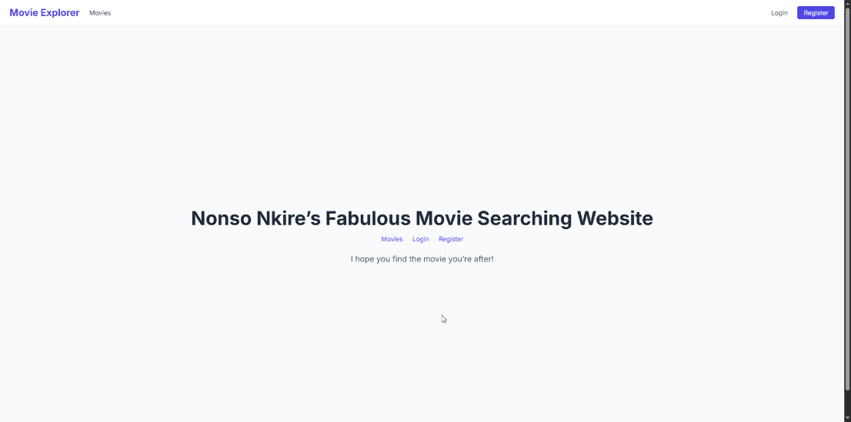Users are greeted with to a welcoming home page that provides links to navigate to the movies page, login, and register pages.

*Figure 13: Home page*

### Registering a New Account

Clicking on the “register” link redirects users to a form where they can create a new account using an email and password. After successfully creating an account, the user is redirected to the login page where they can then login.

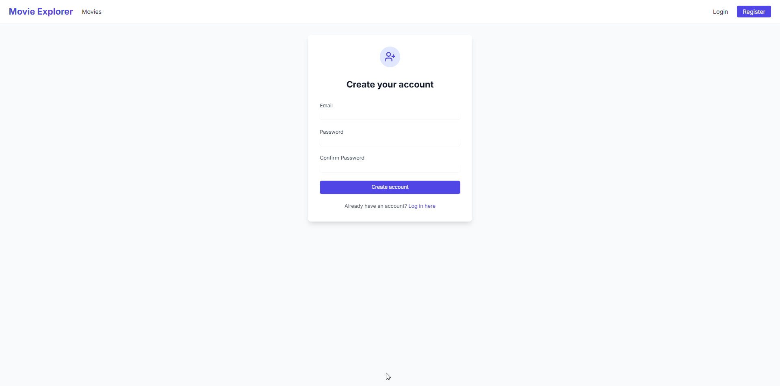

*Figure 14: Registration page*

### Logging In

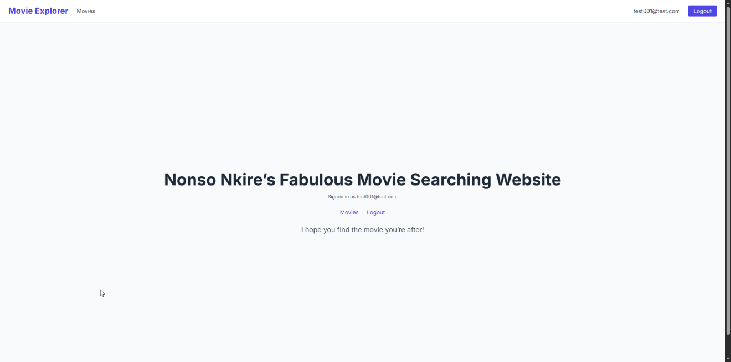Successful login displays user’s email in the top navigation bar and on the home page and unlocks access to protected features like person details.

*Figure 15: Logged-in user*

### Browsing and Searching Movies

Here, users can:

* Search by movie title
* Filter by year
* Browse results using pagination controls
* 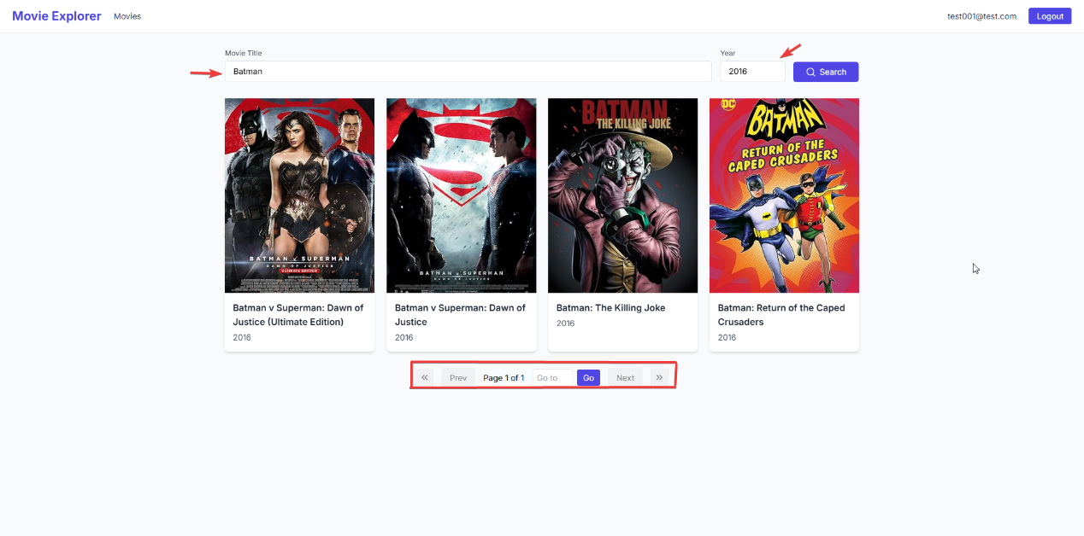Click on a movie card to see full details

*Figure 16: Movies page (example showcasing search and filter function, and pagination controls)*

### Movie Details

Clicking on a movie card opens its details page. Here users can see:

* The movie poster, runtime, release year and release countries
* Ratings from IMDb, Rotten Tomatoes, and Metacritic
* 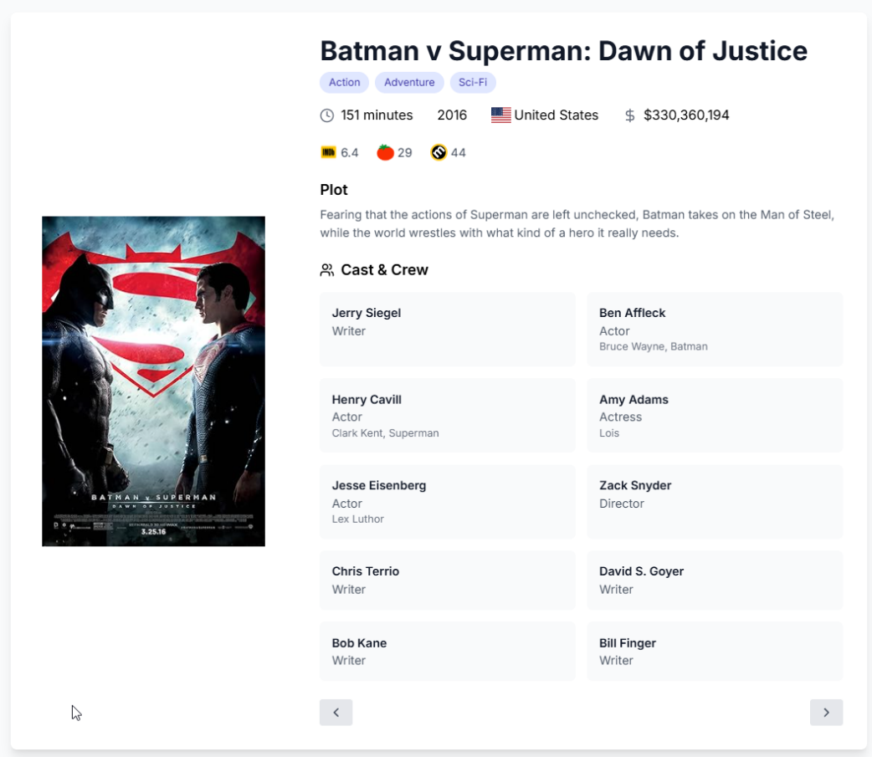Cast and crew, with links to their filmography (if authenticated)

*Figure 17: Movie details page*

### Person Details

Clicking on a cast/crew members name brings up their profile page, which includes:

* Filmography table (sortable and paginated)
* Bar chart visualizing IMDb ratings of the movies the individual has been involved in.

If an unauthenticated user attempts this, they are redirected to the register page with a toast message.

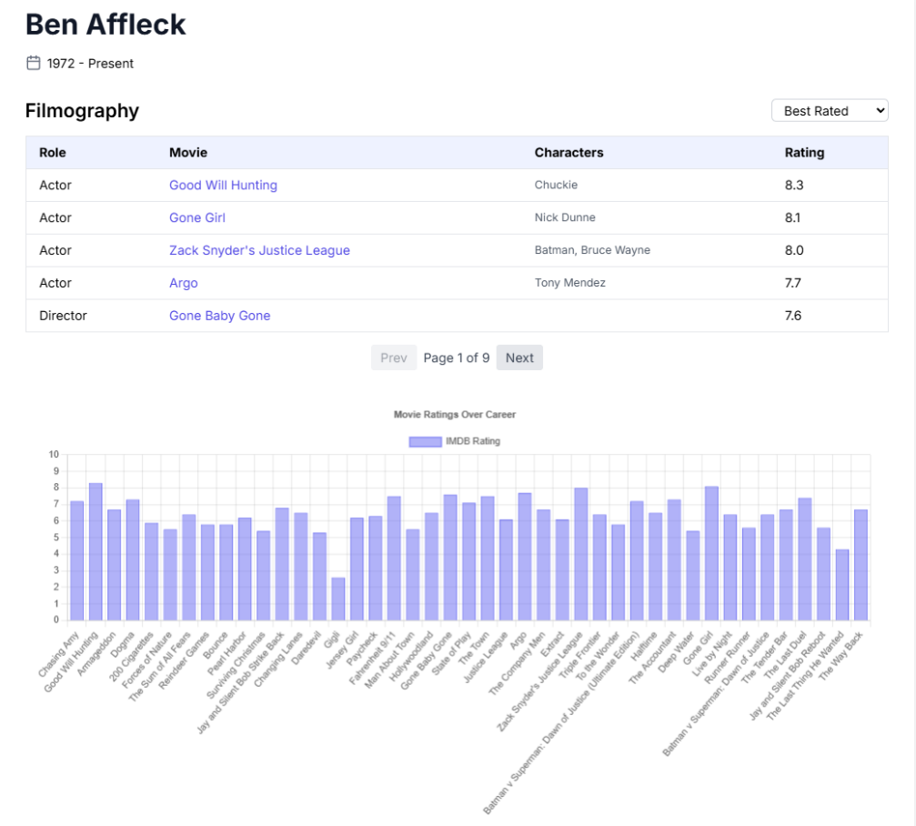

*Figure 18: Person details page showing filmography and rating chart.*

### Logging out

Clicking the logout button on either the home page or the navbar clears the stored tokens and returns the user to an unauthenticated state. Protected routes become inaccessible until re-authentication.

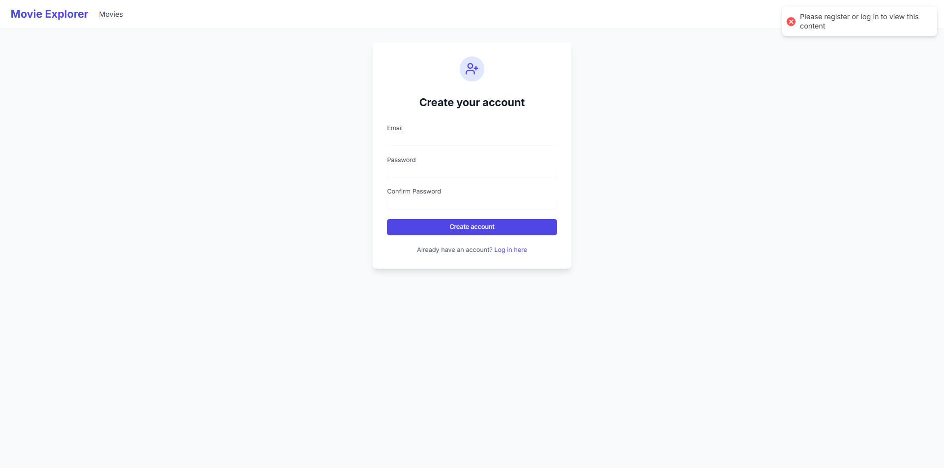

*Figure 19: Toasting confirming logout and navbar post-logout*

## References

reza. (2020, August 19). *Template Design Vector Hd PNG Images, Film Logo Design Template Vector Isolated Illustration, Film Clipart, Black, Element PNG Image For Free Download*. Pinterest; pngtree. https://www.pinterest.com/pin/templat-design-vector-hd-png-images-film-logo-design-template-vector-isolated-illustration-film-clipart-black-element-png-image-for-free-download--761178774513171796/

## Appendices

### 01



### 02



### 03



### 04



### 05



### 06



### 07



### 08



### 09



### 10



### 11



### 12



### 13



### 14

